A SIMPLE 24-bit COMPUTER SYSTEM

By

Nikko Brian Caraan

Carlos Rafael Catalan

Melvin Flores

Klarence Manangan

CMSC 132 T-3L

Computer Architecture

The goal of this project is to create a simple computer that can support a 24-bit input with the first 8-bits dedicated to an instruction and the remaining 16 bits for two operands with 8 bits each. The design will have 8 general purpose registers (named r1,r2,...,r8), 2 8-bit Memory Address Registers, 1 8-bit Program Counter, 1 8-bit Instruction Counter and 1 8-bit Flag functioning as zero flag and sign flag(the first most significant bits for the zero flag and the last 4 bits for the sign flag). The project will also have a mapping of the opcode to the machine code, assign a register to a register number in binary and specify the chosen ALU, Data path and Control Unit Design.

PROBLEM STATEMENT:

Can the design function as a simple computer?

Mapping of opcode to Machine Code

|  |  |  |  |  |  |
| --- | --- | --- | --- | --- | --- |
| **Constants** | **Assembly Instruction** | **First Byte** | **Second Byte** | **Third Byte** | **Operation** |
| **LOAD** | **LOAD Rn, direct** | **00000000** | Rn | Direct | Rn ⭠ M(direct) |
| **STORE** | **STORE direct, Rn** | **00000001** | Direct | Rn | M(direct) ⭠ Rn |
| **SAVE** | **SAVE Rn, Immediate (?)** | **00000010** | Rn | Immediate | Rn ⭠ |
| **INC** | **INC Rn, Rm** | **00000011** | Rn | Rm | Rn ⭠ Rn + Rm (1) |
| **DEC** | **DEC Rn, Rm** | **00000100** | Rn | Rm | Rn ⭠ Rn – Rm (1) |
| **ADD** | **ADD Rn, Rm** | **00000101** | Rn | Rm | Rn ⭠ Rn + Rm |
| **SUB** | **SUB Rn, Rm** | **00000110** | Rn | Rm | Rn ⭠ Rn – Rm |
| **MUL** | **MUL Rn, Rm** | **00000111** | Rn | Rm | Rn ⭠Rn * Rm |
| **DIV** | **DIV Rn, Rm** | **00001000** | Rn | Rm | Rn ⭠Rn/Rm |
| **CMP** | **CMP Rn, Rm** | **00001001** | Rn | Rm | Rn ⭠Rn-Rm |
| **AND** | **AND Rn, Rm** | **00001010** | Rn | Rm | Rn ⭠Rn and Rm |
| **OR** | **OR Rn, Rm** | **00001011** | Rn | Rm | Rn ⭠Rn or Rm |
| **NOT** | **NOT Rn, Rm** | **00001100** | Rn | Rm | Rm ⭠ not Rn |
| **XOR** | **XOR Rn, Rm** | **00001101** | Rn | Rm | Rn ⭠ Rn xor Rm |
| **JE** | **JE Rn, Rm** | **00001110** |  |  |  |
| **JG** | **JG Rn, Rm** | **00001111** |  |  |  |
| **JL** | **JL Rn, Rm** | **00010000** |  |  |  |
| **JMP** | **JMP Rn, Rm** | **00010001** |  |  |  |

THE INSTRUCTON SET

Data Transfer Instructions

**LOAD**

Format: **LOAD** <register>, <memory address>

Description: Loads data from the specified memory address to the given register

**STORE**

Format: **STORE** <memory address>, <register>

Description: Stores data from the specified register address to the given memory address

**SAVE**

Format: **SAVE** <register>, <memory address>

Description: Loads data from the specified memory address to the given register

Arithmetic Instructions

**INC**

Format: **INC** <register1>, <register2>

Description: Increments the value in register2 and saves the result to register1

**DEC**

Format: **DEC** <register1>, <register2>

Description: Decrements the value in register2 and saves the result to register1

**ADD**

Format: **ADD** <register1>, <register2>

Description: Adds the value of register1 to the register2 and stores the result in register1

**SUB**

Format: **SUB** <register1>, <register2>

Description: Subtracts the value of register2 to the register1 and stores the result in register1

**MUL**

Format: **MUL** <register1>, <register2>

Description: Multiply the value of register1 by register2 and stores the result in register1

**DIV**

Format: **DIV** <register1>, <register2>

Description: Divides the value of register1 by register2 and stores the result in register1

Comparison Instructions

**CMP**

Format: **CMP** <register1>, <register2>

Description: Multiply the value of register1 by register2 and stores the result in register1

Logic Instructions

**AND**

Format: **AND** <register1>, <register2>

Description: Performs bitwise AND operation between register1 and register2 and stores the result in register1

**OR**

Format: **OR** <register1>, <register2>

Description: Performs bitwise OR operation between register1 and register2 and stores the result in register1

**NOT**

Format: **NOT** <register1>, <register2>

Description: Performs bitwise NOT operation on register1 and stores the result in register2

**XOR**

Format: **XOR** <register1>, <register2>

Description: Performs bitwise XOR operation between register1 and register2 and stores the result in register1

Jump Instructions

**JE**

Format: **JE** <register1>, <register2>

Description:

**JG**

Format: **JG** <register1>, <register2>

Description:

**JL**

Format: **JL** <register1>, <register2>

Description:

**JMP**

Format: **JMP** <register1>, <register2>

Description:

|  |  |
| --- | --- |
| Constants | Assembly Instruction |
| LOAD | LOAD Rn, direct |
| STORE | STORE direct, Rn |
| SAVE | SAVE Rn, Immediate (?) |
| INC | INC Rn, Rm |
| DEC | DEC Rn, Rm |
| ADD | ADD Rn, Rm |
| SUB | SUB Rn, Rm |
| MUL | MUL Rn, Rm |
| DIV | DIV Rn, Rm |
| CMP | CMP Rn, Rm |
| AND | AND Rn, Rm |
| OR | OR Rn, Rm |
| NOT | NOT Rn, Rm |
| XOR | XOR Rn, Rm |
| JE | JE Rn, Rm |
| JG | JG Rn, Rm |
| JL | JL Rn, Rm |
| JMP | JMP Rn, Rm |

THE ALU

Since we are designing a 24-bit computer, the ALU therefore would accept 24-bit input.

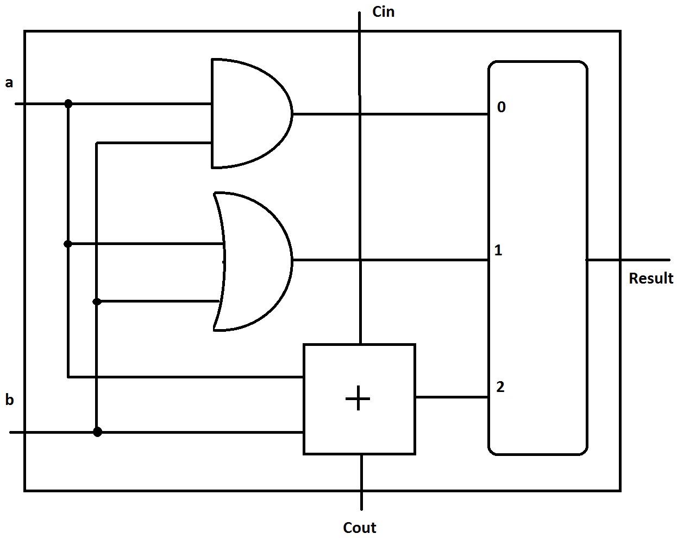

1-bit ALU

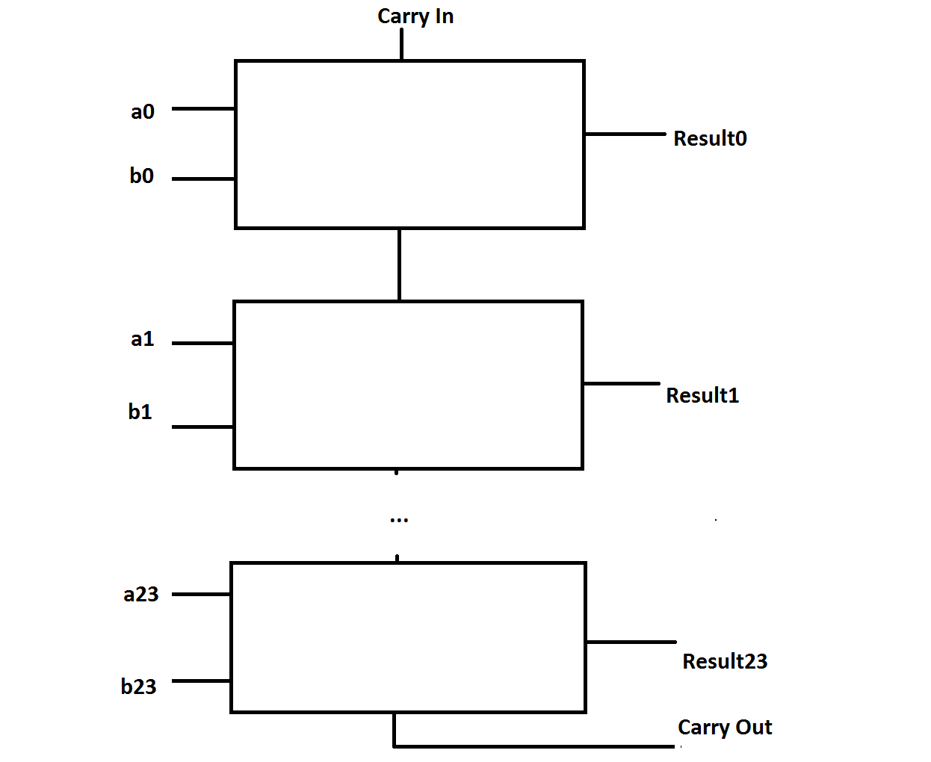

24-bit ALU

A number of functions are performed internally but only one result is chosen as the output of the ALU. A 24- bit ALU is just the compilation of 24 identical 1-bit ALUs.

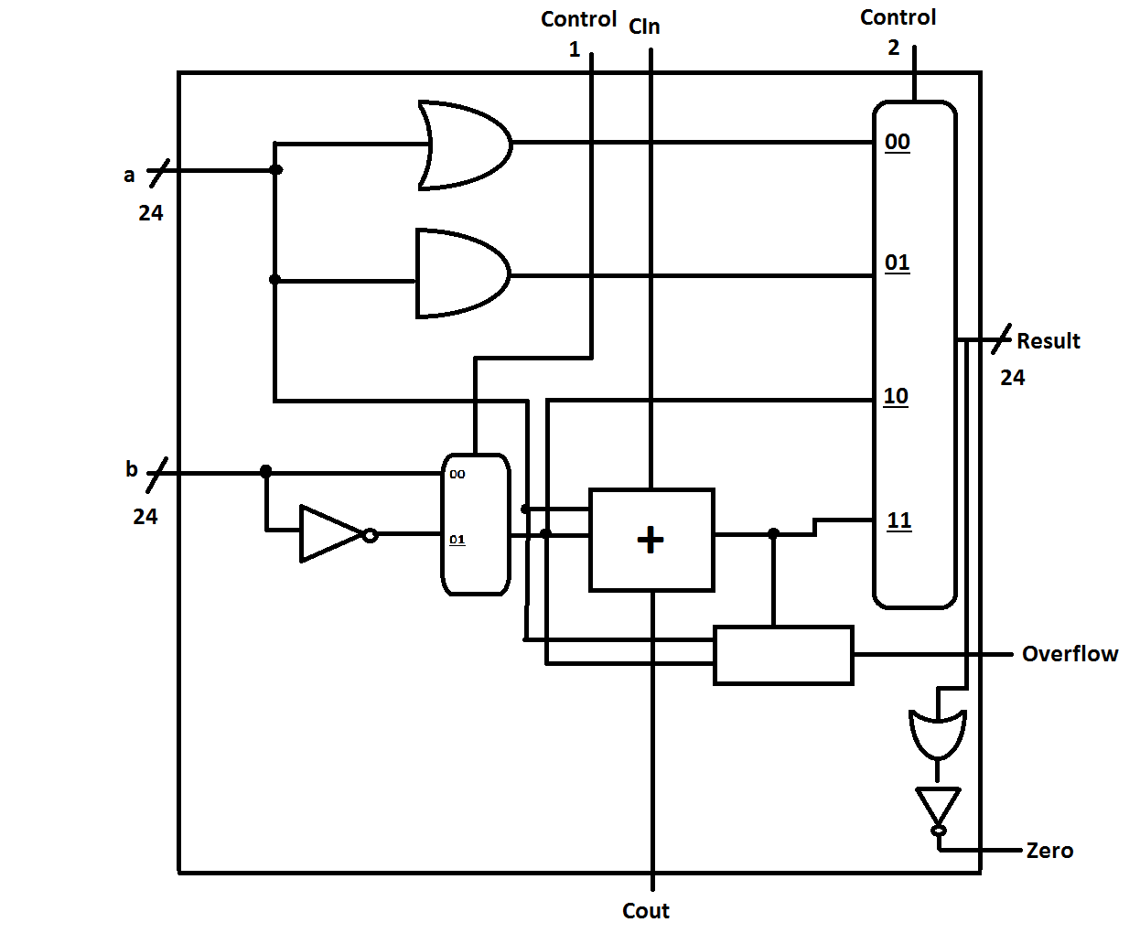

Data Path Design

R1s

R2s

RFs

To Control Unit

MEMORY

ALU

RF()

MUX

MUX

MUX

ALU sign

ALU op

ALU zero

R2s

R1s

RFs

***DATAPATH***

MUX

ALU

MUX

MUX

RF

CONTROL

UNIT

MEMORY

This is the simple system’s data path. The execution of an instruction is expected to run in one clock cycle. This design may be improved further to support pipelining.

Control Unit Design

**.**

DATAPATH

***CONTROL UNIT***

MBR

PC

IR

CLK

CONTROL

SIGNALS

CONTROLLER

MEMORY

**.**

**.**

PC inc

PC clr

MAR

Conclusion

The group was able to create a design for a simple computer using the various components created.

The group was also able to design all the required components as specified in the project specifications. (Control Unit, Arithmetic Logic Unit, Mapping of Opcode and Operands, Register Assignments and Datapath design)

Each of the components would function properly on its own as well as with other components, ensuring the proper functioning of the computer once implemented.

**References**

ALU Design. (n.d.). Retrieved May 2, 2016, from http://www.utdallas.edu/~poras/courses/ee3320/xilinx/upenn/lab5-ALUDesign.htm

Manuales P., Payoyo, N. Garcia, G. & Santos, J. (n.d.) A Simple Computer System: Implementation in VHDL.

Pardo, A. (2013, August 30). *How a data path works inside a computer system*.

Retrieved from https://www.youtube.com/watch?v=ibYYqvp9FmU

Pardo, A. (2013, August 21). *How a control unit works inside a CPU*.

Retrieved from https://www.youtube.com/watch?v=ZyPewh04OzQ

Meadow, C. *Control Unit Operation*.

Retrieved from http://aturing.umcs.maine.edu/~meadow/courses/cos335/COA15.pdf